Test Case Table of Contents (Only Tests that Failed are Listed):

1 2 3 Comments

**Test Case 1: Client name filter is selected and a valid client name (Waye) is entered**

Results:

* Despite the client having ordered 3 different products, only 1 product appears
* total is computed properly for the single product (isa lang kasi so kung ilan yung order dun sa product, yun na yung total. lol)
* 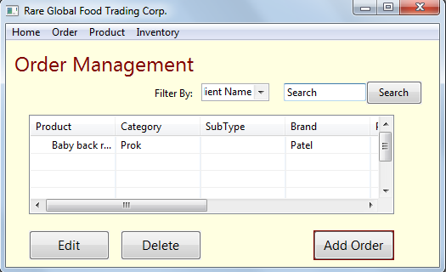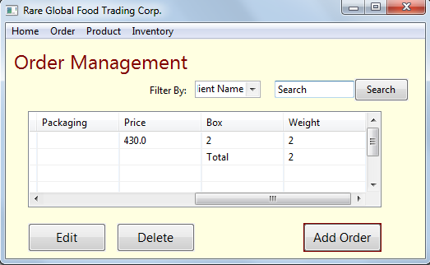

**Test Case 2: Client name filter is selected and a valid client name (Thomas) is entered (this was done again using the window that was used in Test Case 1)**

Results:

* The table entry is added 2 rows after the entry from the previous test case (hindi nacclear yung table)
* The table entry adds one product that was ordered by the entered client name (same problem as test case 1, isa lang yung product na lumalabas)
* Total computes weirdly (Lets say the previous client ordered 2 and the current client ordered 2. The total computes both client’s orders which is 4 pero hindi dapat kasi different clients and different products un eh)
* 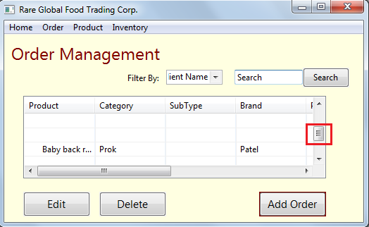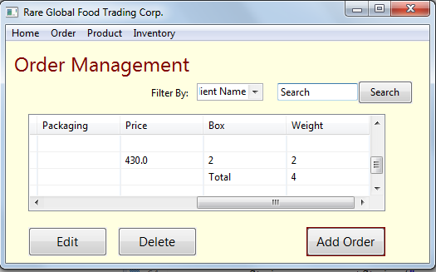

**Test Case 3: Client name filter is selected and a valid client name (Thomas) is entered (app is restarted)**

Results:

* Results are the same with test case 1
* 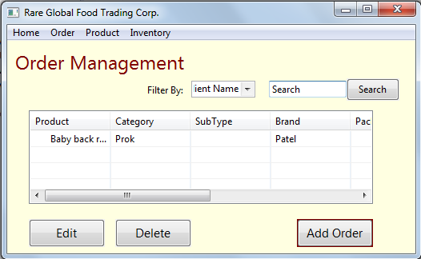

Comment: Feel ko yung **first line item** based on the searched client name lang yung inooutput nung app

**(SUCCESS!) Test Case 4: Client name filter is selected but client name field is left blank**

Results:

* App informs the user of an invalid input

**(SUCCESS!) Test Case 5: Due date filter and a date are selected**

Results:

* App properly outputs the products ordered on the selected date
* Total is computed properly

**(SUCCESS!) Test Case 6: Due date filter and a date are selected but no order exists on the selected date**

Results:

* App informs the user of an invalid input

**(SUCCESS!) Test Case 7: Client name filter is selected after due date filter was used**

Results:

* Due date filter displays product properly, and client filter result (which only includes the first line item product) is placed below the due date filter results
* Total is computed properly

**(SUCCESS!) Test Case 8: Due date filter is selected after client name filter was used**

Results:

* Same results with test case 8 but order of the displays of the selected filters are swapped (since the order of the filters were swapped also)

**(SUCCESS!) Test Case 9: View “All” filter is selected**

Results:

* All product orders are displayed properly

**(SUCCESS!) Test Case 10: View “Pending” filter is selected**

Results:

* All product orders are displayed properly

**(SUCCESS!) Test Case 11: View “Delivered” filter is selected**

Results:

* All product orders are displayed properly

Comments:

* Dapat ata magcclear yung table if nagselect ng bagong filter?
* If possible, palakihin sana yung window tapos gawing unresizable kasi nareresize nga yung window pero yung table for display hindi. Haha
* If possible, palakihin rin sana yung table for display. Hirap kasi magscroll pa para lang maview yung buong row ☺
* Question: wala akong nakitang ganiyang UI dun sa UI mock ups, final na ba ‘to?